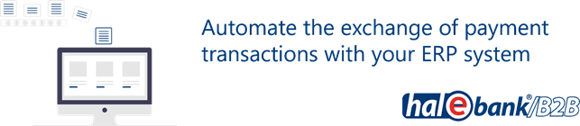

Order form for Hal E-Bank

1. Fill out the order form

Customer: |  |  |  |  | Tax number:
Address:
Contact person: |  |  |  |  | Tel.:
E-mail:
Contact person (IT): |  |  |  |  | Tel.:
E-mail (IT):
Installation method
Remote access |  |  | On location:
The price list of services is available on the website PRICELIST.
At HALCOM d.d. we order the following services (tick):

Installation of multi-user version of Hal E-Bank/Corporate; includes the installation of the IBM DB2 database on server, two Hal E-Bank/Corporate clients and one-year right to use additional support (tel. no. 01 / 200-33-69)
Installation of multi-user version on additional clients
Upgrade of database on the existing server
Transfer of database to a new server
Transfer of multi-user version Hal E-Bank/Corporate to single-user version Hal E-Bank/Personal
One-year additional support service Basic
One-year additional support service Pro
Intervention
Multimarket functionality
Additionally:

By signing this order form, I am ordering additional support services for an indefinite period of time. After one year from the installation, Halcom charges in advance for the additional support service according to the valid price list of Corporate services published on the PRICE LIST. The Additional Support Service may be modified or canceled in writing up to and including seven days before the end of the annual period of use of the Services.
The Basic support package includes assistance with installing additional Hal E-Bank / Corporate clients, assistance with troubleshooting Hal E-Bank / Corporate issues, and assistance with troubleshooting issues with the installed version of DB2. This is the default package when ordering a Hal E-Bank / Corporate license.

In addition to the contents of the Basic package, the Additional Pro support package also includes the implementation of Multimarket functionality, assistance in resolving related problems and one transfer of the database every two completed years of payment for Pro support.
The one-year additional support service is payable within eight days on the basis of the issued invoice.

Order date: |  | Responsible person:
Customer's stamp: |  | Responsible person's signature:

LEGAL NOTICE
Halcom d.d. performs work and services under this order in accordance with the applicable Halcom General Terms and Conditions for Support and Maintenance. Client is solely responsible for providing an up-to-date backup of data and information prior to installing the software or in the event of any tampering with servers or workstations.

In no event shall Halcom be liable for any damages resulting from the loss of data and information.

2. Send the signed and stamped order form:
- Scanned to an e-mail address helpdesk@halcom.si,
- Or by post to: Halcom d.d., Dunajska cesta 123, 1000 Ljubljana.

3. Halcom's call
After receiving the order, we will call you to agree on the date of the selected service and check the available hardware and software. We perform the ordered service on a previously agreed date.
The order form is valid for 1 month after sending.

