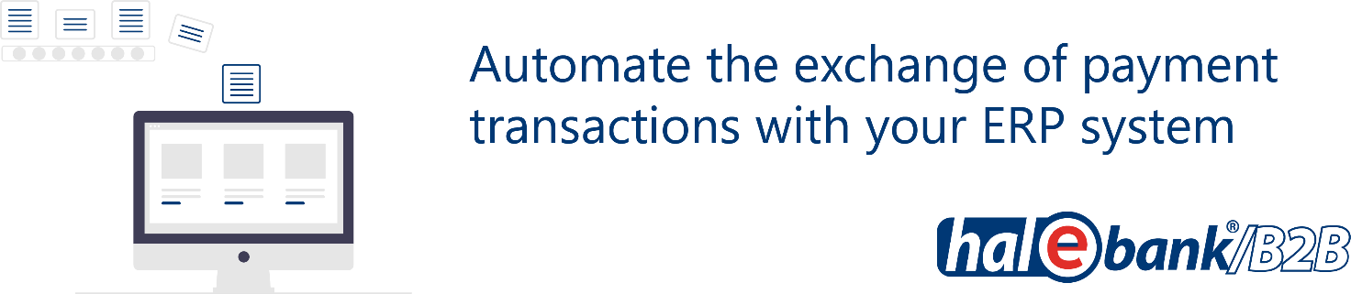

Purchase order for Hal E-Bank

1. Fill out the order form

Customer: |  |  |  |  | Tax number:
Address:
Contact person: |  |  |  |  | Tel.:
E-mail:
Contact person (IT): |  |  |  |  | Tel.:
E-mail (IT):
Installation method
Remote access |  |  | On location:

At HALCOM d.d. we order the following services (tick):

Installation of multi-user version of Hal E-Bank/Corporate; includes the installation of the IBM DB2 database on server, two Hal E-Bank/Corporate clients and one-year right to use additional support (tel. no. 01 / 200-33-69)
Installation of multi-user version on additional clients
Upgrade of database on the existing server
Transfer of database to a new server
Transfer of multi-user version Hal E-Bank/Corporate to single-user version Hal E-Bank/Personal
One-year additional support service
Intervention
Additionally:

By signing this form, I order additional support services for an indefinite period. After one year from the installation, Halcom charges additional support service in advance at amount of € 70/year. The additional support service may be canceled in written form up to 7 days before the end of the annual period of use of the services.
The additional support service includes answers to questions received by phone (01/200-33-69) or e-mail (helpdesk@halcom.si) and relates to:
- help with troubleshoot issues related to the use of IBM DB2
- assistance with installing IBM DB/2 database clients
- help with backups
- assistance with installation of Hal E-Bank/Corporate
The one-year additional support service is payable within eight days on the basis of the issued invoice.

Order date: |  | Responsible person:
Customer’s stamp: |  | Responsible person’s signature:

LEGAL NOTICE
Halcom d.d. performs work and services under this order in accordance with the applicable Halcom General Terms and Conditions for Support and Maintenance. Client is solely responsible for providing an up-to-date backup of data and information prior to installing the software or in the event of any tampering with servers or workstations.

In no event shall Halcom be liable for any damages resulting from the loss of data and information.

2. Send the signed and stamped order form:
- by fax on 01/200-33-56,
- scanned to an e-mail address helpdesk@halcom.si,
- or by post to: Halcom d.d., Tržaška cesta 118, 1000 Ljubljana.

3. Halcom’s call
After receiving the order, we will call you to agree on the date of the selected service and check the available hardware and software. We perform the ordered service on a previously agreed date.

